Design pattern for file transfer

Perfect — constraining this to On-premises ↔ Azure over ExpressRoute only simplifies things and lets us design very clean, deterministic, enterprise-grade patterns.
Below is a segregated design-pattern catalog per Azure resource type, aligned to:
✔ ExpressRoute (private, predictable bandwidth)
✔ One-time & continuous uploads
✔ Large files (MB → GB)
✔ No data loss / no corruption
✔ Security tiers (High / Medium / Low)
✔ Performance tuning guidance

0️⃣ Common Baseline (Applies to ALL Patterns)
Network
- ExpressRoute Private Peering
- No public endpoints
- Private DNS resolution
- MTU tuned (jumbo frames where supported)
Transfer Guarantees
- Chunking / multipart upload
- Parallel streams
- Resume support
- Checksum validation (MD5 / SHA-256)
- Idempotent commits
Why ExpressRoute helps
- No internet jitter
- Predictable throughput
- Stable long-running uploads
- Lower packet loss → fewer retries
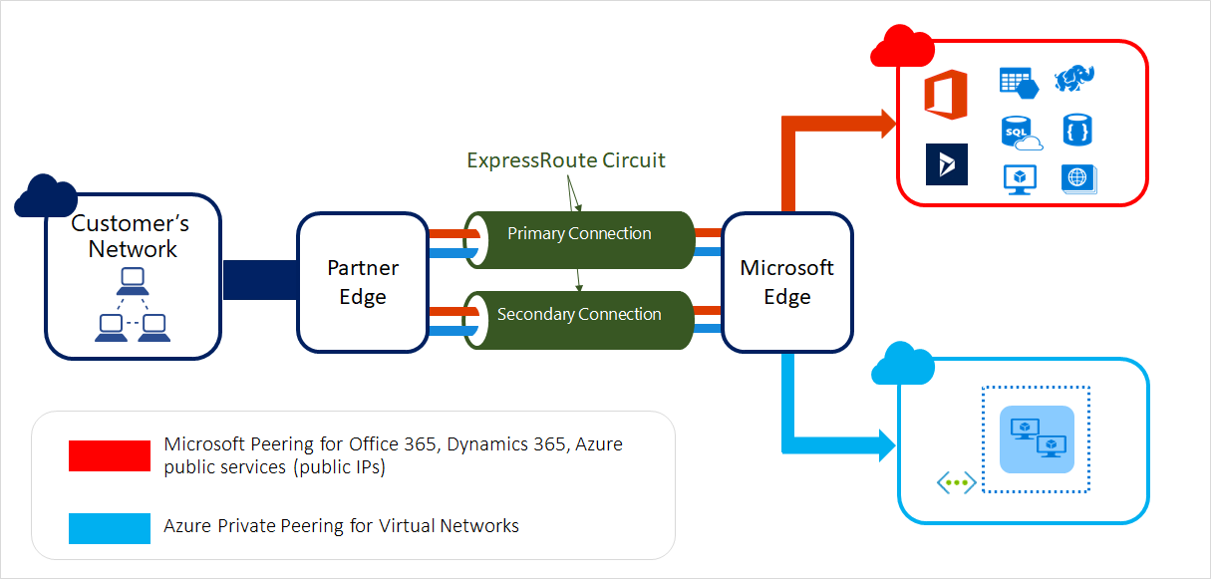

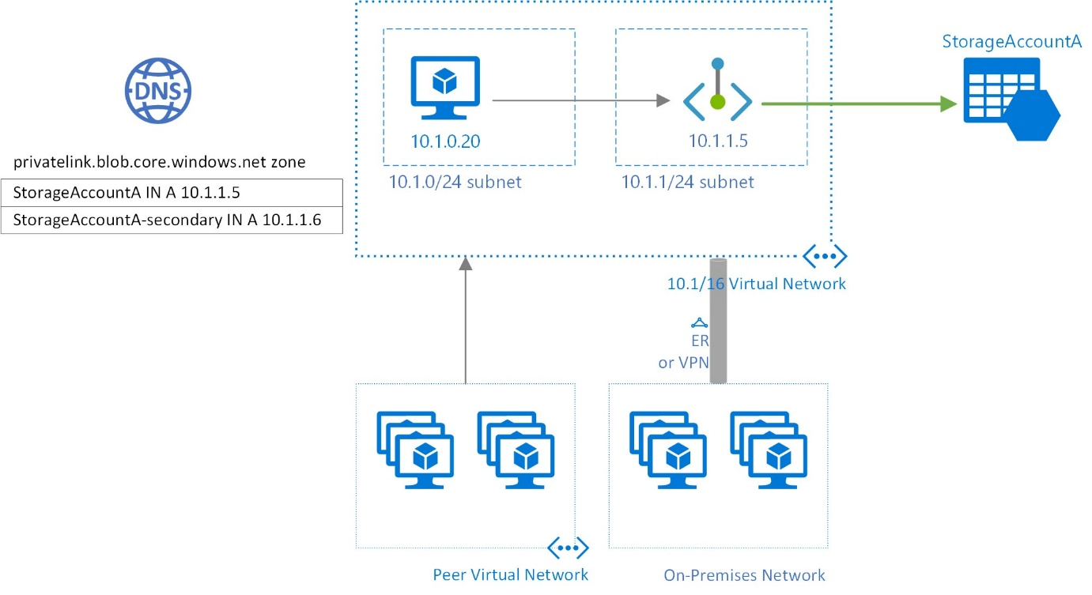

1️⃣ Azure Blob Storage (Object Storage)
Primary destination for large files

1.1 HIGH SECURITY – Blob Storage (Recommended Default)
Use When
- PII / financial / regulated data
- Zero public exposure
- Strict audit & compliance
Architecture
On-prem App / Server
↓
ExpressRoute
↓
VNet
↓
Private Endpoint
↓
Azure Blob Storage
Controls
Layer | Design
Identity | Managed Identity / Entra ID
Network | Private Endpoint only
AuthZ | RBAC + container-level scope
Encryption | TLS + CMK (Key Vault)
Integrity | Per-block MD5 + final hash
Audit | Storage Analytics + Defender
Upload Pattern
- Block Blob
- Multipart upload
- Commit block list only after verification
Performance Tuning
File Size | Chunk Size | Parallelism
1–100 MB | 4–8 MB | 4
100 MB–1 GB | 32–100 MB | 8–16
>1 GB | 100–400 MB | 16–32

1.2 MEDIUM SECURITY – Blob Storage
Differences
- SAS token instead of full RBAC
- SAS scoped to:
  - Container
  - Write-only
  - Short TTL (15–60 mins)
Pattern
On-prem
↓ (SAS)
Multipart Upload
↓
Blob Storage (Private Endpoint)
✔ Faster onboarding
✔ Still private via ExpressRoute

1.3 LOW SECURITY – Blob Storage
Use When
- Non-sensitive bulk data
- Internal-only datasets
Pattern
- Storage firewall allows ExpressRoute subnet
- Account key auth
- Still multipart + checksum
⚠️ Only acceptable for internal, non-regulated data

2️⃣ Azure SQL Database (PaaS)
Rule: Azure SQL is NEVER the upload target for large files

2.1 Correct Design Pattern (ALL Security Levels)
Architecture
On-prem
↓
ExpressRoute
↓
Blob Storage (Private Endpoint)
↓
Validate checksum
↓
Insert metadata into Azure SQL
What goes into SQL
- Blob URL (private)
- File hash
- Size
- Version
- Status
If ingestion is required
- COPY INTO (from Blob)
- BULK INSERT
- Azure Data Factory (ExpressRoute IR)

2.2 Anti-Patterns (Do NOT do this)
❌ VARBINARY(MAX) for GB files
❌ Direct streaming uploads to SQL
❌ Long transactions holding file data

3️⃣ Azure Virtual Machines (IaaS)

3.1 HIGH SECURITY – VM as Target
Use When
- Legacy apps
- File system dependency
- Custom processing
Architecture
On-prem
↓
ExpressRoute
↓
VNet
↓
Azure Bastion / Jump Host
↓
VM (Private IP only)
Transfer Methods
Method | Use Case
AzCopy | Large files, resumable
SCP / SFTP | Controlled, slower
SMB over ER | Lift-and-shift
Integrity
- Hash validation on VM
- Retry per chunk
- Temp location + atomic move

3.2 MEDIUM SECURITY – VM Pull Model (Recommended)
Pattern
On-prem → Blob Storage
↓
VM pulls file
✔ Better resilience
✔ No inbound VM exposure
✔ Easier retries

3.3 LOW SECURITY – VM Direct Push
- SCP over ER
- No Bastion
- Minimal controls
⚠️ Acceptable only for non-prod

4️⃣ Azure File Storage (SMB / NFS)

4.1 Enterprise File Transfer Pattern
Use When
- Shared files
- Legacy apps
- Lift-and-shift
Architecture
On-prem File Server
↓
ExpressRoute
↓
Azure Files (Private Endpoint)
Notes
- SMB Multichannel for performance
- Azure File Sync for continuous replication
- Slower than Blob for large files

5️⃣ One-Time vs Continuous Upload (ExpressRoute)

One-Time (Migration / Bulk Load)
✔ Larger chunks
✔ Higher parallelism
✔ AzCopy / ADF
On-prem
↓
Parallel multipart upload
↓
Blob Storage

Continuous Upload (Feeds / Pipelines)
✔ Smaller chunks
✔ Append or rolling blocks
✔ Back-pressure handling
On-prem Agent
↓
Chunked upload
↓
Blob → Event Grid → Processing

6️⃣ Performance Optimization Over ExpressRoute
TCP / Transport
- Increase TCP window size
- Disable Nagle where possible
- Multiple parallel connections
Storage
- Use Premium Blob for high throughput
- Avoid small block sizes (<1 MB)
- Pre-allocate upload sessions

7️⃣ Summary Table (Quick Reference)
Azure Resource | Recommended Upload Target | Pattern
Blob Storage | ✅ YES | Multipart + Private Endpoint
Azure SQL DB | ❌ NO | Metadata only
Azure VM | ⚠️ Conditional | Prefer pull from Blob
Azure Files | ⚠️ Medium | SMB over ExpressRoute

Final Takeaway
For ExpressRoute-only environments, the gold standard is always:
On-prem → ExpressRoute → Blob Storage (Private Endpoint)
Everything else (SQL, VM, analytics) should consume from Blob, not receive uploads directly.

If you want next:
- 🔹 HLD / LLD diagrams per resource
- 🔹 AzCopy tuning parameters for ER
- 🔹 Checksum + retry logic pseudocode
- 🔹 AWS S3 vs Azure Blob internal comparison
Say the word and we’ll go deeper 👌

Got it 👍 — you’re really asking “what do teams ACTUALLY use in real Azure enterprises over ExpressRoute, and why?”
Not the most perfect design on paper, but easy to configure, easy to operate, and reliable.
I’ll be very direct and practical here.

✅ What is MOST USED in Azure (On-prem → Azure over ExpressRoute)
🥇 #1 — AzCopy → Azure Blob Storage (Private Endpoint)
This is the de-facto standard.
If you walk into 10 Azure enterprises, 7–8 of them are using this.
Why AzCopy wins
✔ Zero code
✔ Works over ExpressRoute
✔ Built-in multipart upload
✔ Resume on failure
✔ Checksum validation
✔ CLI + scriptable
✔ Supported & battle-tested by Microsoft
Typical Pattern
On-prem server
↓
AzCopy
↓ (ExpressRoute)
Azure Blob Storage (Private Endpoint)
Setup Effort
Item | Difficulty
Private Endpoint | Easy
DNS (privatelink) | Easy
RBAC / SAS | Easy
AzCopy config | Very Easy
Performance
- Auto-chunking
- Auto-parallelism
- Uses maximum available bandwidth
👉 This is the default recommendation unless you have special needs.

🥈 #2 — Azure File Sync (for file-server style workloads)
Used heavily for lift-and-shift scenarios.
When teams choose this
✔ Existing Windows file servers
✔ Continuous sync required
✔ Minimal app changes
Pattern
On-prem File Server
↓
Azure File Sync Agent
↓ (ExpressRoute)
Azure Files
Pros
- Extremely easy to configure
- Continuous replication
- No custom scripts
Cons
- Slower than Blob for large files
- Less control over chunking
- Not ideal for very large (GB+) objects

🥉 #3 — ADF (Azure Data Factory) – used when “data pipelines” exist
Used mostly by:
- Data teams
- Analytics platforms
- ETL workloads
Pattern
On-prem
↓
Self-Hosted IR
↓
Azure Data Factory
↓
Blob / SQL / Data Lake
Reality check
✔ Powerful
❌ Overkill for simple file uploads
❌ More expensive
❌ Slower to configure

❌ What is RARELY used (even though architects talk about it)
Pattern | Why it’s rare
Custom upload APIs | Too much code
Direct SQL uploads | Bad performance
Direct VM SCP | Hard to manage
Event-driven upload services | Over-engineering

📊 Ease-of-Use Comparison (Real-World)
Option | Ease | Config | Ops | Performance | Adoption
AzCopy → Blob | ⭐⭐⭐⭐⭐ | ⭐⭐⭐⭐ | ⭐⭐⭐⭐⭐ | ⭐⭐⭐⭐⭐ | Very High
Azure File Sync | ⭐⭐⭐⭐ | ⭐⭐⭐⭐ | ⭐⭐⭐⭐ | ⭐⭐⭐ | High
ADF | ⭐⭐⭐ | ⭐⭐ | ⭐⭐⭐ | ⭐⭐⭐⭐ | Medium
Custom API | ⭐ | ⭐ | ⭐ | ⭐⭐⭐⭐ | Low

🔐 Security vs Simplicity Sweet Spot
Most enterprises choose this exact combo:
✔ ExpressRoute
✔ Private Endpoint
✔ AzCopy
✔ Short-lived SAS OR Managed Identity
✔ Blob Storage
No public exposure, no custom code, minimal effort.

🧠 Simple Decision Rule (use this)
Is this file-based and large?
└── Yes → Blob Storage

Do you want easiest setup?
└── Yes → AzCopy

Is it continuous file-server sync?
└── Yes → Azure File Sync

Is this a data pipeline?
└── Yes → ADF

🏆 Final Answer (Plain English)
The most used, easiest, and safest solution is:
👉 AzCopy over ExpressRoute into Azure Blob Storage (Private Endpoint)
Everything else is secondary and only chosen when there’s a very specific requirement.

If you want, I can:
- Give exact AzCopy commands & flags
- Share ExpressRoute tuning tips
- Provide security baseline (RBAC/SAS templates)
- Convert this into a 1-page architecture standard
Just tell me 👍

Perfect, this is the right narrowing question 👍
Let’s answer it cleanly, practically, and honestly, based on what actually works best from small KB files to multi-GB files over ExpressRoute.

✅ One Solution That Works from Small → Very Large Files
🏆 Azure Blob Storage + AzCopy
This is the only Azure-native option that scales smoothly from KB-sized files to multi-GB files without changing architecture.

Why Blob + AzCopy fits ALL sizes
File size coverage
File size | Works well? | Why
100 KB – 1 MB | ✅ Yes | Simple PUT
1 MB – 100 MB | ✅ Yes | Auto chunking
100 MB – 1 GB | ✅ Yes | Parallel multipart
>1 GB | ✅ Yes | Resume + checksum
You don’t need to redesign when file size grows — AzCopy automatically adapts.

How it behaves by size (behind the scenes)
Small files (KB–MB)
- Single or minimal blocks
- Low overhead
- Near-instant uploads
Medium files (10–100 MB)
- Splits into multiple blocks
- Parallel uploads
- Faster than SMB / SCP
Large files (100 MB–GBs)
- Multipart upload
- Resumable
- Block-level retries (no restart)
This is exactly how S3 multipart upload works, implemented natively in Azure.

Compared with other options (size-wise)
Option | Small files | Medium files | Large files | Verdict
AzCopy → Blob | ⭐⭐⭐⭐⭐ | ⭐⭐⭐⭐⭐ | ⭐⭐⭐⭐⭐ | Best overall
Azure File Sync | ⭐⭐⭐⭐ | ⭐⭐⭐ | ⭐⭐ | Not for large files
ADF | ⭐⭐⭐ | ⭐⭐⭐⭐ | ⭐⭐⭐⭐ | Overkill
SCP / SFTP | ⭐⭐ | ⭐⭐ | ⭐ | Poor scaling
Direct SQL | ❌ | ❌ | ❌ | Never

Why enterprises standardize on this
✔ Same tool for all sizes
✔ Same security model
✔ Same network path (ExpressRoute)
✔ Same monitoring & retry logic
✔ No custom code
One pattern, zero rework later

Simple rule (memorize this)
Any file size?
Any frequency?
Any environment?
→ Use Blob Storage + AzCopy
Everything else is a specialization, not a replacement.

When you might NOT use it (edge cases)
Scenario | Alternative
Millions of tiny files | Zip → Blob
Continuous file server sync | Azure File Sync
Streaming logs | Append Blob
ETL pipelines | Azure Data Factory

Final, straight answer
Azure Blob Storage with AzCopy is suitable for both small-size data and very large-size data — without changing the design.
If you want, next I can:
- Show exact AzCopy tuning for small vs large files
- Give recommended block sizes
- Map this to AWS S3 multipart
- Provide a decision flowchart
Just say the word 👌

Great question — this is exactly the kind of problem where design patterns matter more than tools. I’ll structure this so you can reuse it for architecture reviews, interviews, or real deployments.
Below is a practical, Azure-first design pattern catalog for secure, reliable, high-performance large file transfer across Storage Accounts, Azure SQL (PaaS), and Azure VMs, covering:
• Security tiers (high / medium / low)
• One-time vs continuous uploads
• File sizes: KB → multi-GB
• No data loss / no corruption guarantees
• Performance optimization (multipart, parallelism, resume)

1️⃣ Core Principle (applies to ALL designs)
Never upload large files as a single stream
Use:
- Chunking / Multipart upload
- Parallel transfers
- Checksum validation
- Resume support
- Idempotent commits
This is how S3, Azure Blob, GCS all work internally.
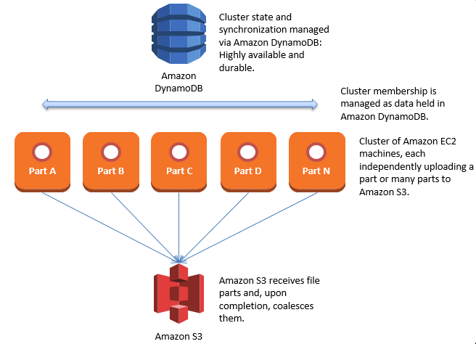
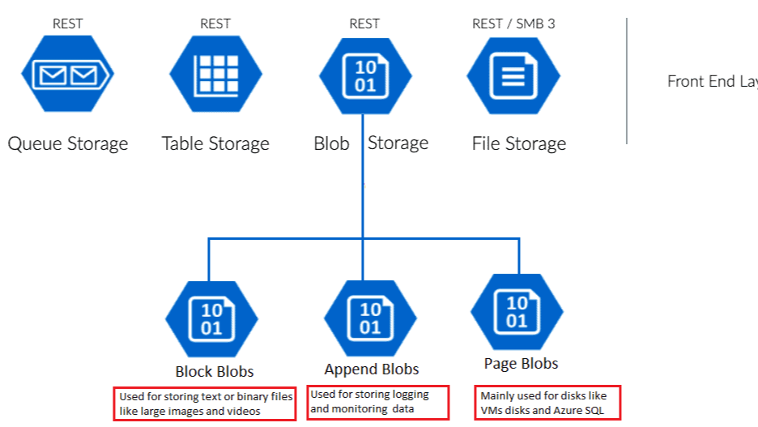
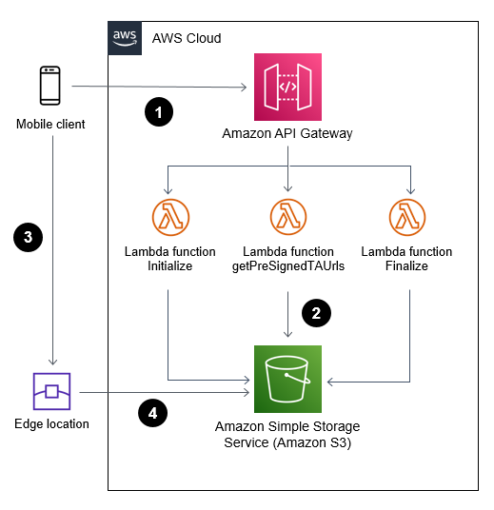

2️⃣ Security-Based Design Patterns
🔐 HIGHLY SECURE (Regulated / PII / Financial)
Use when
✔ PII / PHI / financial data
✔ Compliance (ISO, SOC, HIPAA)
✔ Zero trust, no public exposure
Architecture Pattern
Client
↓ (Private Endpoint)
Azure Front Door (optional WAF)
↓
Azure API Management (auth, throttling)
↓
Upload Service (App Service / Function)
↓
Azure Blob Storage (Private Endpoint)
Security Controls
Layer | Control
Identity | Entra ID OAuth2 / Managed Identity
Network | Private Endpoint + VNet injection
AuthZ | RBAC + scoped SAS (write-only)
Encryption | TLS 1.2+, CMK (Key Vault)
Integrity | MD5 / SHA-256 per chunk
Audit | Storage Analytics + Defender
Upload Strategy
- Block Blob multipart upload
- Chunk size: 4–100 MB
- Parallel uploads: 4–16 threads
- Commit only after checksum validation
SQL PaaS (Azure SQL)
⚠️ Do NOT upload large files directly
- Upload to Blob
- Store URL + hash in SQL
- Optional: Azure SQL BULK INSERT from Blob

🔐 MEDIUM SECURITY (Enterprise Internal Apps)
Use when
✔ Internal workloads
✔ Controlled access
✔ Performance > compliance
Architecture Pattern
Client / VM / App
↓
SAS Token (time + IP scoped)
↓
Azure Blob Storage
Controls
- HTTPS only
- Short-lived SAS (5–30 mins)
- Storage firewall (selected VNets)
- Defender for Storage
Upload Strategy
- SDK-based multipart upload
- Resume on failure
- Retry with exponential backoff

🔓 LOW SECURITY (Non-sensitive / Public Data)
Use when
✔ Public datasets
✔ Logs, telemetry dumps
✔ Cost & speed first
Architecture Pattern
Client
↓
Public Blob Endpoint (HTTPS)
Controls
- HTTPS only
- Container-level access
- No secrets on client
⚠️ Still validate:
- File size
- Content type
- Hash

3️⃣ Destination-Specific Design Patterns

🟦 Azure Blob Storage (Object Storage)
Best choice for large files
File Size | Recommended Pattern
100 KB – 1 MB | Single PUT
1 MB – 100 MB | Chunked (4–8 MB)
100 MB – 1 GB | Multipart + parallel
>1 GB | Multipart + resume + checksum
Blob Types
- Block Blob → uploads
- Append Blob → logs / streams
- Page Blob → VM disks (NOT uploads)

🟩 Azure SQL Database (PaaS)
🚫 Anti-pattern: uploading binaries directly
✅ Correct Pattern
Upload file → Blob
↓
Validate hash
↓
Insert metadata into SQL
If ingestion needed:
- COPY INTO
- BULK INSERT
- Azure Data Factory

🟨 Azure VMs
Scenario | Best Method
One-time upload | AzCopy
Continuous | Blob + agent pull
Secure | SCP over Bastion
High volume | Blob mount (Blobfuse / SMB)

4️⃣ Performance Optimization Matrix
Chunk Size vs Throughput
Network Speed | Chunk Size | Parallelism
100 KB–1 MB/s | 1–4 MB | 2–4
1–10 MB/s | 4–16 MB | 4–8
10–100 MB/s | 32–100 MB | 8–16
>100 MB/s | 100 MB+ | 16–32
💡 Azure Blob max block size = 4000 MB, max blocks = 50,000

5️⃣ Data Integrity & No-Loss Guarantees
Mandatory Controls
✔ Per-chunk checksum
✔ Final object hash
✔ Idempotent commit
✔ Retry with same block ID
✔ Server-side validation
Failure Handling
Upload chunk fails
↓
Retry same block ID
↓
Resume upload
↓
Commit only when all blocks validated

6️⃣ One-Time vs Continuous Upload
One-Time (Migration)
- AzCopy
- ADF
- Offline chunking
- Higher chunk sizes
Continuous (Streaming / Feeds)
- Append Blob
- Event Grid trigger
- Rolling files (time-based)
- Smaller chunks

7️⃣ Storage Model Comparison (When to Use What)

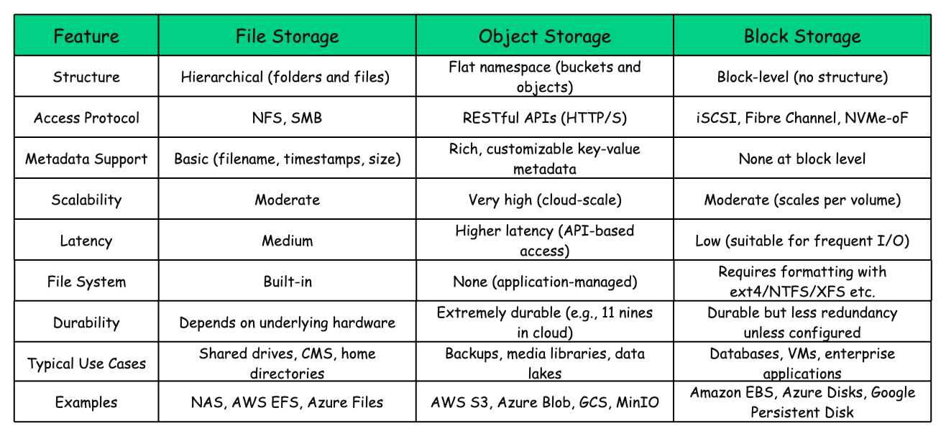
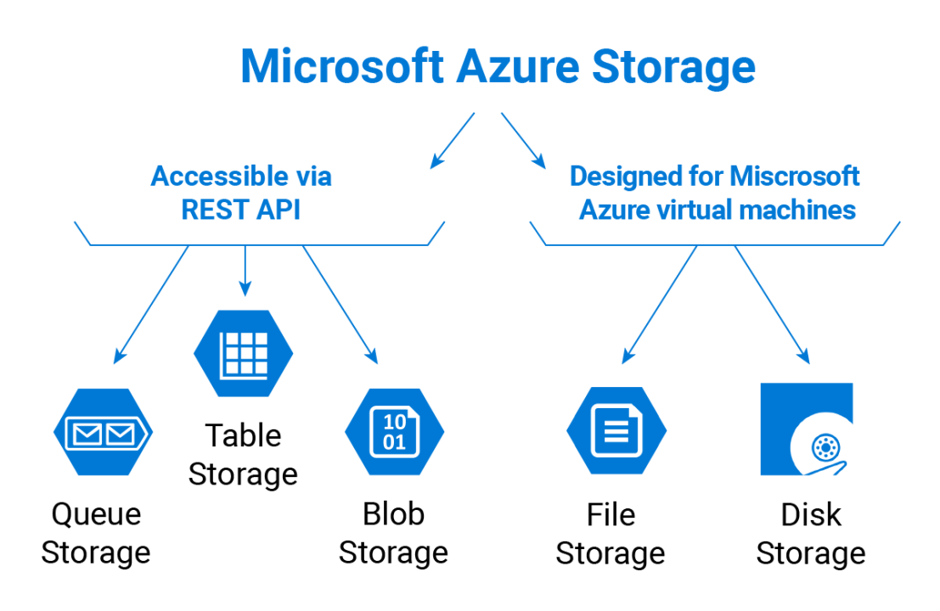
Type | Use Case
Block | DBs, VM disks
File | Shared file systems
Object | Large files, backup, archives

8️⃣ Reference “Gold Standard” Azure Pattern
Client
↓
SAS (short-lived)
↓
Multipart Upload (Blob)
↓
Checksum validation
↓
Commit block list
↓
Event Grid → Processing / SQL metadata
✔ Secure
✔ Fast
✔ Resumable
✔ Cloud-native

9️⃣ Common Anti-Patterns (avoid these)
❌ Uploading >100MB directly to SQL
❌ Single PUT for GB-size files
❌ Long-lived SAS tokens
❌ Public storage for sensitive data
❌ No checksum validation

If you want, I can:
- Draw Azure reference diagrams (HLD/LLD)
- Map this to AWS S3 vs Azure Blob internals
- Provide AzCopy / SDK sample configs
- Convert this into an enterprise design standard doc
Just tell me how deep you want to go 🚀

Great question — you’re essentially asking for design patterns for secure, reliable, and performant large file transfers across Azure services (Storage Account, PaaS SQL DB, VMs), with considerations for security tiers, upload modes, and file sizes. Let’s break this down systematically.

🔐 Security Design Patterns for File Transfer
Security Tier | Design Pattern | Key Features | Use Cases
Highly Secure | End-to-End Encryption + Private Network Transfer | - Use HTTPS/TLS 1.2+ for transport<br>- Encrypt files at rest with AES-256<br>- Use Azure Private Link or ExpressRoute<br>- Employ Managed Identity & RBAC<br>- Integrity check with MD5/SHA256 | Financial data, healthcare records, sensitive IP
Medium Secure | Secure Upload with Public Endpoint + SAS Tokens | - Use HTTPS<br>- Generate short-lived SAS tokens for access<br>- Encrypt at rest (Storage Service Encryption)<br>- Integrity check with ETag/MD5 | Enterprise file sharing, logs, backups
Less Secure | Basic HTTPS Upload + Shared Keys | - Use HTTPS<br>- Shared access keys<br>- Minimal encryption (default storage encryption)<br>- Limited integrity checks | Non-sensitive media, test data, temporary files

📂 Upload Modes
- One-time Uploads
  - Use Azure Blob Storage Block Blob with Put Blob or Multipart Upload.
  - For SQL DB, use BULK INSERT or Azure Data Factory.
  - For VMs, use AzCopy or SCP over SSH.
- Continuous Uploads (Streaming/Batch)
  - Use Event Grid + Blob Storage for ingestion.
  - Use Azure Data Factory / Synapse Pipelines for continuous ingestion into SQL DB.
  - Use File Sync or rsync for VM-based workloads.

⚡ Performance Optimization by File Size
File Size Range | Recommended Strategy | Tools/Techniques
100KB – 1MB | Direct upload (single PUT/POST) | HTTPS PUT, AzCopy
1MB – 10MB | Chunked upload with retries | AzCopy, Blob REST API
10MB – 100MB | Multipart upload (split into 4–8MB blocks) | Blob Block Upload, ETags
100MB – 1GB | Multipart upload with parallel threads | AzCopy, Storage SDKs, Data Factory

🛠 Multipart Upload Pattern (Optimized for Large Files)
- Initiate Upload → Client requests upload session, gets uploadID.
- Split File → Break into chunks (e.g., 200MB each for 1.6GB file).
- Upload Parts → Each part uploaded with uploadID.
- Verify Integrity → Server returns ETag (MD5 checksum).
- Commit Upload → Client sends list of parts + ETags.
- Reassembly → Storage reassembles file, returns success.
This ensures:
- No data loss (checksum validation).
- Resumable uploads (retry failed chunks).
- Parallelism (upload multiple chunks simultaneously).

🚀 Azure-Specific Optimization Techniques
- Azure Blob Storage
  - Use Block Blob + AzCopy for high throughput.
  - Enable parallelism (--parallel-level in AzCopy).
  - Use SAS tokens for secure temporary access.
- Azure SQL PaaS DB
  - Use BULK INSERT or BCP utility for large datasets.
  - For continuous ingestion, use Azure Data Factory with staging in Blob Storage.
- Azure VMs
  - Use AzCopy, SCP over SSH, or Azure File Sync.
  - For very large files, use Managed Disks snapshot + attach.

✅ Summary
- Security tiers: Private Link + encryption (high), SAS tokens (medium), shared keys (low).
- Upload modes: One-time (AzCopy, BULK INSERT), Continuous (Data Factory, Event Grid).
- Performance: Multipart upload with retries + parallelism for files >10MB.
- Integrity: Always validate with checksums (MD5/SHA256, ETags).

👉 If you’d like, I can sketch out architecture diagrams for each security tier (high/medium/low) showing how file transfer flows across Azure Storage, SQL DB, and VMs. Would you like me to create those diagrams?

/ upload large files to Storage account, Azure PaaS SQL DB, Azure VMs, etc, need highly secure, medium secure and less secure design pattern, ensuring no data loss or corruption, one time upload or continuous upload, having speed between 100KB to 1MB, 1MB to 10MB, 10 MB to 100MB, 100MB to 1GB

How can we optimize performance when we 𝐮𝐩𝐥𝐨𝐚𝐝 𝐥𝐚𝐫𝐠𝐞 𝐟𝐢𝐥𝐞𝐬 to object
storage service such as Storage account, Azure PaaS SQL DB, Azure VMs, etc?
Before we answer this question, let's take a look at why we need to
optimize this process. Some files might be larger than a few GBs. It is
possible to upload such a large object file directly, but it could take a
long time. If the network connection fails in the middle of the upload,
we have to start over. A better solution is to slice a large object into
smaller parts and upload them independently. After all the parts are
uploaded, the object store re-assembles the object from the parts. This
process is called 𝐦𝐮𝐥𝐭𝐢𝐩𝐚𝐫𝐭 𝐮𝐩𝐥𝐨𝐚𝐝.
The diagram below illustrates how multipart upload works:



- The client calls the object storage to initiate a multipart upload. 2. The data store returns an uploadID, which uniquely identifies the upload. 3. The client splits the large file into small objects and starts uploading. Let’s assume the size of the file is 1.6GB and the client splits it into 8 parts, so each part is 200 MB in size. The client uploads the first part to the data store together with the uploadID it received in step 2. 4. When a part is uploaded, the data store returns an ETag, which is essentially the md5 checksum of that part. It is used to verify multipart uploads. 5. After all parts are uploaded, the client sends a complete multipart upload request, which includes the uploadID, part numbers, and ETags. 6. The data store reassembles the object from its parts based on the part number. Since the object is really large, this process may take a few minutes. After reassembly is complete, it returns a success message to the client.

What happens when you upload a file to Amazon S3? Let’s design an S3 like object storage system

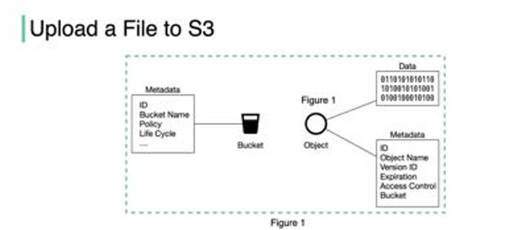

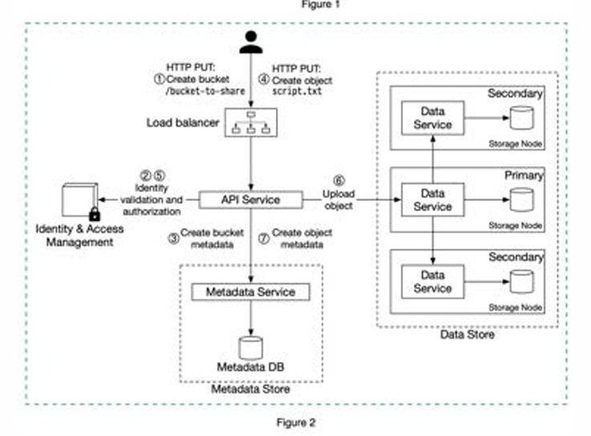

Before we dive into the design, let’s define some terms

� �𝐮𝐜𝐤𝐞𝐭. A logical container for objects. The bucket name is globally unique. To upload data to S3, we must first create a bucket. 𝐎𝐛𝐣𝐞𝐜𝐭. An object is an individual piece of data we store in a bucket. It contains object data (also called payload) and metadata. Object data can be any sequence of bytes we want to store. The metadata is a set of name-value pairs that describe the object. An S3 object consists of (Figure 1): 🔹 Metadata. It is mutable and contains attributes such as ID, bucket name, object name, etc. 🔹 Object data. It is immutable and contains the actual data. In S3, an object resides in a bucket. The path looks like this: /bucket-to-share/script.txt. The bucket only has metadata. The object has metadata and the actual data. The diagram below (Figure 2) illustrates how file uploading works. In this example, we first create a bucket named “bucket-to-share” and then upload a file named “script.txt” to the bucket

- The client sends an HTTP PUT request to create a bucket named “bucket-to-share.” The request is forwarded to the API service. 2. The API service calls the Identity and Access Management (IAM) to ensure the user is authorized and has WRITE permission. 3. The API service calls the metadata store to create an entry with the bucket info in the metadata database. Once the entry is created, a success message is returned to the client. 4. After the bucket is created, the client sends an HTTP PUT request to create an object named “script.txt”. 5. The API service verifies the user’s identity and ensures the user has WRITE permission on the bucket.
6. Once validation succeeds, the API service sends the object data in the HTTP PUT payload to the data store. The data store persists the payload as an object and returns the UUID of the object. 7. The API service calls the metadata store to create a new entry in the metadata database. It contains important metadata such as the object_id (UUID), bucket_id (which bucket the object belongs to), object_name, etc.

Block storage, file storage and object storage Yesterday, I posted the definitions of block storage, file storage, and object storage. Let’s continue the discussion and compare those 3 options

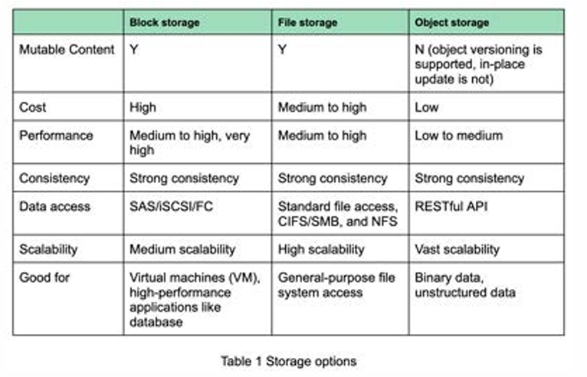

Block storage, file storage and object storage
In this post, let’s review the storage systems in general.
Storage systems fall into three broad categories:
🔹
Block storage
🔹
File storage
🔹
Object storage
The diagram below illustrates the comparison of different storage
systems.



𝐁𝐥𝐨𝐜𝐤 𝐬𝐭𝐨𝐫𝐚𝐠𝐞 Block storage came first, in the 1960s. Common storage devices like hard disk drives (HDD) and solid-state drives (SSD) that are physically attached to servers are all considered as block storage. Block storage presents the raw blocks to the server as a volume. This is the most flexible and versatile form of storage. The server can format the raw blocks and use them as a file system, or it can hand control of those blocks to an application. Some applications like a database or a virtual machine engine manage these blocks directly in order to squeeze every drop of performance out of them. Block storage is not limited to physically attached storage. Block storage could be connected to a server over a high-speed network or over industry-standard connectivity protocols like Fibre Channel (FC)

and iSCSI. Conceptually, the network-attached block storage still presents raw blocks. To the servers, it works the same as physically attached block storage. Whether to a network or physically attached, block storage is fully owned by a single server. It is not a shared resource. 𝐅𝐢𝐥𝐞 𝐬𝐭𝐨𝐫𝐚𝐠𝐞 File storage is built on top of block storage. It provides a higher-level abstraction to make it easier to handle files and directories. Data is stored as files under a hierarchical directory structure. File storage is the most common general-purpose storage solution. File storage could be made accessible by a large number of servers using common file-level network protocols like SMB/CIFS and NFS. The servers accessing file storage do not need to deal with the complexity of managing the blocks, formatting volume, etc. The simplicity of file storage makes it a great solution for sharing a large number of files and folders within an organization.

𝐎𝐛𝐣𝐞𝐜𝐭 𝐬𝐭𝐨𝐫𝐚𝐠𝐞 Object storage is new. It makes a very deliberate tradeoff to sacrifice performance for high durability, vast scale, and low cost. It targets relatively “cold” data and is mainly used for archival and backup. Object storage stores all data as objects in a flat structure. There is no hierarchical directory structure. Data access is normally provided via a RESTful API. It is relatively slow compared to other storage types. Most public cloud service providers have an object storage offering, such as AWS S3, Google block storage, and Azure blob storage

